

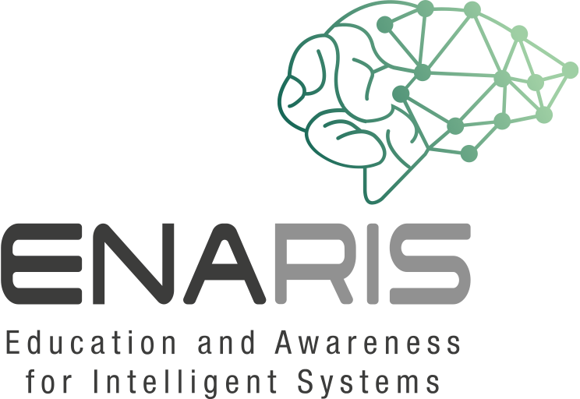
Talk With A Chatbot!
Form groups of 3-4 people
Take a closer look at the chatbot Mitsuku (nickname Kuki)!
https://chat.kuki.ai
Log in and solve the following exercises.
Stop the time while talking with Mitsuku!
How long does it take for you to realize that this isn't human? How did you recognize that this is a computer system?

- What happens when statements are repeated?
- What happens if you phrase the same question differently?
- How can you tell that you are talking to a machine?
- Does the chatbot always give logical answers to your questions? How does the chatbot react if it doesn't understand something?
- Do you have to write whole sentences or are single words enough for the chatbot? Does he interpret these individual words correctly?
- Provide precise examples/quotes from your conversations with the chatbot! What could be done better, so that it does appear more human?
- Should it even appear more human?

